

2.4: Creating Variables in Python Walkthrough

Variables are values which are able to change depending on the current conditions of the program. Python supports a number of different types:

* Numbers
  + Integers
  + Long (also integers, just bigger! – they can be represented as octal or hexadecimal numbers)
  + Float (essentially decimal numbers)
  + Complex numbers (involves imaginary numbers in the format $x + yj$, where $j^{2}=-1$– you will not need to worry about these at the moment ☺)
* String
* Lists
* Tuples
* Dictionary (work on key-value pairs, whereby the key is the unique identifier, and the value is the data to be held)

To demonstrate how variables can be created and used, we will be building on the Hello World project you have just completed. The first thing to do is create a new variable. We are going to call it name, and assign it a value of “bob”:

name = “bob”

In Python, and all other programming languages, the equals sign (=) allows you to assign a value to a variable.

We then need to update our print() statement to use the name variable:

print(“Hello, World and ” + name)

Note: the + symbol when working with strings is seen as the concatenation operator (so it will link the two strings together. This is carries out the same task as we saw last week when linked two pieces of text together within the print statement with a comma. In the case where we use the + symbol, we need to make sure that there is a space after the last word in the first string, as the space will not be automatically added.

The completed file should look like this:

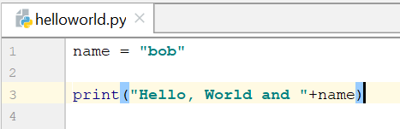

When you run the program, you should get the following output:

